Test Plan and Testing Results for the
MEPAS Vadose Zone Transport Module

1.0 Background and Scope

This paper presents a test plan and the baseline testing results for the Multimedia Environmental Pollutant Assessment System (MEPAS) vadose zone transport module (version 1.2). The purpose of the vadose zone transport module is to simulate the migration and fate of chemical and radionuclide constituents through partially saturated geologic media (i.e., vadose zones). The vadose zone transport module is specifically designed as an object for inclusion into the Framework for Risk Analysis in Multimedia Environmental Systems (FRAMES), which is a platform that allows for the linking of various multimedia modules into complete transport/exposure assessment systems (Whelan et al., 1997).

The vadose zone transport module is being tested for MEPAS version 4.1 and FRAMES version 1.1. The suite of test cases developed for this testing, and presented in this paper, will also be used for assessing the effects of future code modifications. Each time a modification is made to the program code, these test cases are rerun, and their results are compared to the previous run (regression testing). Changes in the results are evaluated to determine if they were expected due to the modification and are an acceptable change, or they are an unintended side effect. In the latter case, the program code can be changed and the testing performed again.

As currently designed, the vadose zone module consists of three components: a Module User Interface (MUI), a pre-processor, and the model itself. The MUI (VAD.EXE - version date) obtains the medium physical properties from the user and stores this data in the Global Input Data (GID) file. The pre-processor (PREVAD.EXE - version date) reads the GID file and the Water Flux File (WFF) and prepares a model specific input file (*.WIN). The model (RADCON.EXE - version 06/18/1999) reads the *.WIN file, performs the simulation, and outputs the results directly to the WFF. The following sections list the requirements of the vadose zone transport module, explains how these requirements relate to the specific test cases in this plan, and then presents the test cases themselves.

2.0 Requirements

Requirements for the vadose zone transport module are described in the paper entitled, Requirements for the MEPAS Vadose Zone Transport Module. These requirements have been reworded into the following list of concise, fundamental requirements suitable for testing.

Requirement  Number | Requirement
1 | Simulate contaminant migration for both chemicals and radionuclides through partially saturated porous media (i.e., vadose zones) via advection and dispersion in the flow direction
2 | Conserve mass in the simulation
3 | Determine a moisture content for the medium that is consistent with the infiltration rate of water entering the medium and the medium’s physical properties. However, if the computed moisture content is less than the field capacity, use the field capacity as the moisture content.
4 | Be able to account for the ingrowth of progeny resulting from degradation/decay, and be able to handle decay chains with up to 9 members (i.e., one parent and eight progeny)
5 | Compute contaminant mass (or activity) flux exiting the medium and output results to a *.WFF file
6 | Output contaminant mass flux results over a time interval that 1) is sufficient to demonstrate mass conservation, and 2) does not include large intervals where the results are zero or near zero
7 | Have no limits on the number of constituents considered in a scenario
8 | Have no limits on the number of flux records read from the WFF input file
9 | Have no limits on the number of flux records written to the output files
10 | Function within the Windows 95 operating system
11 | Meet the module specifications for FRAMES
12 | Create a warning file (*.WRN) at the start of model execution
13 | When a warning condition occurs, write a warning message to the warning file and continue model execution
14 | The MUI shall operate in Windows 95 and have a standard Windows look and feel
15 | The MUI will have on-line help in an HTML format that provides users with an easy-to-understand description of all input parameters
16 | For all input parameters having dimensions associated with them, the MUI will provide users with a choice of units
17 | The MUI will include a reference feature in which the source of the specified value for each input item can be referenced if the user desires
18 | Although the MUI will convert the dimensions of user input data values into the units needed by the model, the MUI will always display the exact value and units in which the user originally entered each input data item
19 | The MUI will show the range of values allowed for each input data item, when the cursor is positioned on that item, as a scrolling message at the bottom of the screen. When an out-of-range value is entered in a field, the MUI will indicate this by a red background in the input field and a scrolling error message in addition to the allowed range message. Data input values within range are shown with a green field background
20 | The MUI will display the module version number, obtained from the module description (DES) file, in an “About” menu
21 | Account for the effect of adsorption of contaminant to soil particles on travel time through the vadose zone and provide estimated Kd’s for each constituent
22 | The MUI shall require only those data necessary to perform the simulation
23 | Output a list file (*.WLS file) that documents the data actually read in by the model and summarizes intermediate calculation results and simulation results,

The following table shows the relationship between these requirements and the test cases described in Section 3. Although some requirements are applicable to all test cases (e.g., function within Windows 95), this table mainly shows which requirements are intended to be tested by each case. There are no test cases for requirements 8, 12, and 13. This is because the module cannot currently read or write an unlimited number of flux records, and there are no designated warning conditions which could occur during the simulation.

Requirement | Test Case Number
Requirement | 01 | 02 | 03 | 04 | 05 | 06
1 | X | X | X |  |  | X
2 | X |  |  |  |  | X
3 | X | X | X
4 |  | X |  | X
5 | X
6 | X |  |  |  |  | X
7 |  |  |  | X
8
9
10 | X
11 | X |  |  |  | X
12
13
14 | X
15 | X
16 | X
17 | X
18 | X
19 | X
20 | X
21 | X
22 | X
23 | X

3.0 Test Cases and Baseline Testing Results

This section describes the specific test cases used for baseline testing of the MEPAS vadose zone transport module. Calculations performed to determine expected results are shown in Appendix A for the appropriate test cases. Appendix B describes the general procedure for conducting the tests.

3.1 VADOSE01

3.1.1 Description and Rationale

This is a simple case to verify the basic functions of the vadose zone module. One chemical (no degradation) and one radionuclide will be released to a vadose zone layer. The source emission for both constituents will be at steady-state for a duration of approximately 10 times the travel time through the layer. The distribution coefficients (Kd’s) for both constituents will be set to the values computed by the MUI, the radionuclide will produce no progeny, and the half-life of the radionuclide will be approximately equal to the travel time through the layer. The solubility and half-lives for both constituents will be set to the default values obtained by the MUI from the FUI section of the GID file (i.e., from the constituent properties database). The following will be evaluated: 1) user-friendliness of the MUI, 2) on-line help in the MUI, 3) data requested by the MUI, 4) data transfer from the MUI to the GID file, from the GID file to the WIN file, from the WFF to the WIN file, and from the WIN file to the model, 5) mass conservation, 6) calculation of moisture content in the layer, 7) calculation of the pore-water velocity, 8) calculation of the longitudinal dispersion coefficient, 9) use of Kd and calculation of Kd’s by the MUI, 10) calculation of retardation factors, 11) calculation of decay constants, 12) computation of contaminant mass (or activity) flux exiting the medium, 13) the appropriateness of the time interval over which the results are output, and 14) appropriate data written to a *.WLS file.

3.1.2 Input Data

The constituent-specific input data for this case is as follows:

Constituents | Acetone | Tritium (as tritiated water)
Inventory | 130,000 g | 1.3 Ci
Emission Rate | 1000 g/yr | 0.01 Ci/yr
Emission Duration | 130 yrs | 130 yrs
Half-life | n/a | 12.3 yrs

The source dimensions and medium physical properties are as follows:

Source Length | 20 m
Source Width | 25 m
Infiltration Rate (darcian) | 7 cm/yr
Water Flux | 35,000,000 cm³/yr
Soil Type | loam
Soil Type Coefficient | 5.39
Sand Content (Wt. basis) | 42 %
Silt Content (Wt. basis) | 38 %
Clay Content (Wt. basis) | 18 %
Organic Matter Content | 2 %
Iron and Aluminum Content | 0 %
pH | 7.0
Layer Thickness | 3.17 m
Total Porosity | 46.6 %
Field Capacity | 23.5 %
Dry Bulk Density | 1.42 g/cm³
Saturated Hydraulic Conductivity | 3.7 x 10⁻⁴ cm/s
Longitudinal Dispersivity | 0.0317 m

3.1.3 Expected Results

It is expected that the MUI will be easy to use, have a functionality consistent with standard Windows software, and that the on-line help will be clear and correct. It is expected that the reference feature will function properly, a choice of units will be provided for the appropriate input parameters, the range of input values for a data item will scroll across the screen bottom, and green/red background feature will function properly. It is expected that the MUI will request only the following information: soil class, soil type coefficient, sand content, silt content, clay content, organic matter content, iron and aluminum content, pH, layer thickness, total porosity, field capacity, dry bulk density, saturated hydraulic conductivity, longitudinal dispersivity, and Kd’s for both acetone and tritium. It is expected that the MUI will estimate a Kd of 9.60 x 10⁻³ ml/g for acetone, and 0.0 ml/g for tritium (calculations are documented in Appendix A). It is expected that the transfer of data from the MUI to the GID file, from the GID file to the WIN file, and then from the WIN file to the model will occur properly and that any necessary unit conversions will be done correctly. Further, the transfer of information from the WFF through the pre-processor to the WIN file, and then to the model will also occur without error and that any necessary unit conversions will be done correctly. The transfer of data between files can be confirmed by visual inspection of these files (VADOSE01.GID, VADOSE01.WFF, and VADOSE01.WIN) and the transfer of data into the model can be confirmed by visual inspection of the VADOSE01.WLS file. It is also expected that at the start of model execution, a warning file (MEPAS_VZ.WRN) will be created and remain in the workspace after model execution has terminated whether any warning messages occur or not. An error file will also be created at the start of model execution and deleted after model completion if no errors occurred. To test for the creation of this file, terminate model execution early using “ctrl-c” from the keyboard.

It is expected that the model will compute the following: a moisture content for the layer of 27.2 %, a pore-water velocity of 25.7 cm/yr, a longitudinal dispersion coefficient of 272 cm²/yr, a retardation factor for acetone of 1.05, a retardation factor for tritium of 1.00, and a decay constant for tritium of 5.64 x 10⁻² yr⁻¹ (all can be verified by visual inspection of the VADOSE01.WLS file). All of the following results can be confirmed by inspecting VADOSE01.WFF. It is expected that the contaminant mass exiting the medium for acetone will achieve steady-state (after year 13) at a value of 1,000 g/yr. It is expected that the activity of tritium exiting the medium will achieve steady-state (after year 13) at a value slightly less than 5.00 x 10⁹ pCi/yr. This value was arrived at by decaying the flux of tritium from the source for a duration equal to the advective travel time through the layer. The actual steady-state result should be slightly less due to the combined effect of longitudinal dispersion and decay. It is expected that the total mass of acetone exiting the medium will be equal to its starting inventory (130,000 g), and that the activity of tritium exiting the medium will be slightly less than half its starting inventory (0.65 Ci). These values will be written to the VADOSE01.WLS file, but should also be computed from data in the WFF (for verification). Further, it is expected that the time interval over which the results are output will properly define the contaminant mass (or activity) flux without having a large interval over which the results are zero or near zero.

3.1.4 Baseline Testing Results

When setting up this case, the ease-of-use and functionality of the vadose zone module MUI was evaluated. The on-line help for the MUI was reviewed and revised to be more clear and correct. Further, the reference feature, choice of units for the appropriate input parameters, the range of input values for a data item, and the green/red background feature all functioned properly. The MUI requested only the information necessary to perform the simulation (i.e., all required parameters were asked for with no extra parameters being required). The Kd estimations made by the MUI matched the expected results exactly.

The transfer of information from the MUI to the GID file, from the GID file to the model input file, and then from the input file to the model itself was evaluated. All information was transferred correctly and the necessary unit conversions occurred without error. The transfer of information from the input WFF to the model input file and then the model itself was also evaluated. At the start of model execution, a warning file was created, which remained in the workspace after execution was completed (this file contained no actual warning messages). The creation of the error file was checked by issuing “ctrl-c” during model execution. The error file is being created correctly, and is being deleted after the model runs to completion in accordance with the FRAMES specifications.

The model computed the following: a moisture content of 27.20%, a pore-water velocity of 7.06 x 10⁻² cm/day (25.8 cm/yr), a longitudinal dispersion coefficient of 273 cm²/yr, a retardation factor for acetone of 1.05, a retardation factor for tritium of 1.00, and a decay constant for tritium of 5.64 x 10⁻² yr⁻¹. These values either exactly match or are very close to the expected results. The very slight differences that occur are due to small rounding errors caused by unit conversions.

The mass flux of acetone exiting the medium achieved a steady-state value of 1,000 g/yr from 33.8 to 134.5 years. The activity flux of tritium exiting the medium achieved a steady-state value of 4.97 x 10⁹ pCi/yr from 28.4 to 134.6 years. The acetone result matches its expected result exactly, and the tritium result is slightly less than 5.00 x 10⁹ pCi/yr, as expected. The total mass of acetone exiting the medium was 129,999 g, and the total activity of tritium exiting the medium was 0.6459 Ci (calculated from VADOSE01.WFF assuming linear interpolation between data points). Both of these results match the expected results (and the values reported in VADOSE01.WLS) very well, so mass was conserved during the simulation. The time interval over which the output results were reported provided good resolution without any large time periods over which the result was zero or very near zero.

A check was made to locate the WLS file and several parameters were checked to verify that the values input through the MUI were reported correctly.

3.2 VADOSE02

3.2.1 Description and Rationale

The intent of this case is to verify that decay products are handled correctly and to verify that when the computed moisture content is below field capacity, the model will use field capacity as the moisture content. This case will release a chemical and radionuclide constituent (having two decay products) to a vadose zone using an emission duration approximately 1/50 of the travel time through the layer. This should invoke the analytical solution for an instantaneous release (which the code uses to shorten run times) allowing for verification of this solution.

3.2.2 Input Data

The constituent-specific input data for this case is as follows:

Constituents | Trichloroethylene | Curium-245 | Plutonium-241 | Americium-241
Inventory | 51,500 g | 1 Ci | 0.0 Ci | 0.0 Ci
Emission Rate | 5150 g/yr | 0.04 Ci/yr | 0.0 Ci/yr | 0.0 Ci/yr
Emission Duration | 10 yrs | 25 yrs | 1 yrs | 1 yrs
Half-life | n/a | 8490 yrs | 14.4 yrs | 433 yrs

The distribution coefficients (Kd’s) for all constituents well be set to the values computed by the MUI (2.015 ml/g for trichloroethylene, 8.2 ml/g for Curium-245, 10 ml/g for Plutonium-241, and 8.2 ml/g for Americium-241). The source dimensions and medium physical properties are as follows:

Source Length | 25 m
Source Width | 25 m
Infiltration Rate (darcian) | 7.0 cm/yr
Water Flux | 43,750,000 cm³/yr
Soil Type | silt
Soil Type Coefficient | 5.30
Sand Content (Wt. basis) | 7 %
Silt Content (Wt. basis) | 86 %
Clay Content (Wt. basis) | 5 %
Organic Matter Content | 2 %
Iron and Aluminum Content | 0 %
pH | 9.0
Layer Thickness | 9.5 m
Total Porosity | 44.2 %
Field Capacity | 28.8 %
Dry Bulk Density | 1.48 g/cm³
Saturated Hydraulic Conductivity | 1.3 x 10⁻⁴ cm/s
Longitudinal Dispersivity | 0.095 m

3.2.3 Expected Results

It is expected that the model will use the field capacity (28.0 %) as the moisture content, because the calculated moisture content (27.7 %) will be less than field capacity. The time-varying flux of contaminant exiting the medium was calculated using equations in Whelan et al. (1996) and are plotted in the next section along with the actual test results. These calculations are documented in Appendix A.

3.2.4 Baseline Testing Results

The field capacity was used as the moisture content, as expected. The following charts compare the spreadsheet computed flux with the model computed flux exiting the medium for each constituent. For all constituents, an excellent match was obtained indicating that the instantaneous solution and the computation of decay product results in the vadose zone module is functioning as expected.

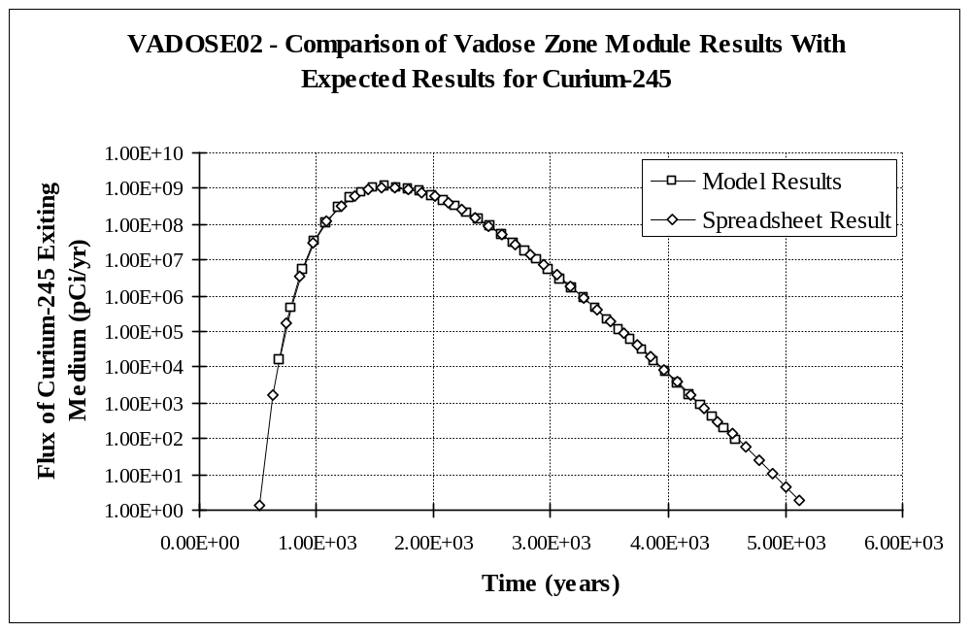

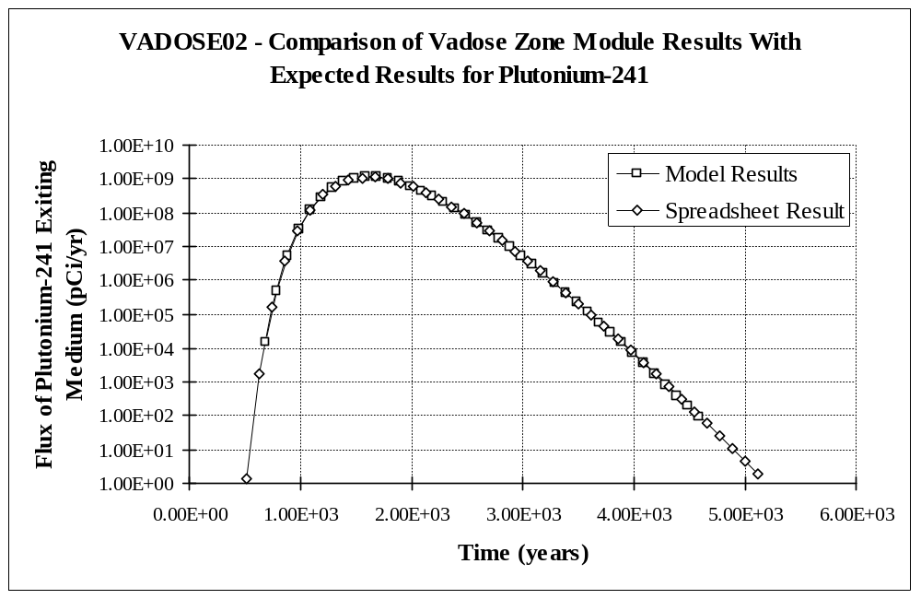
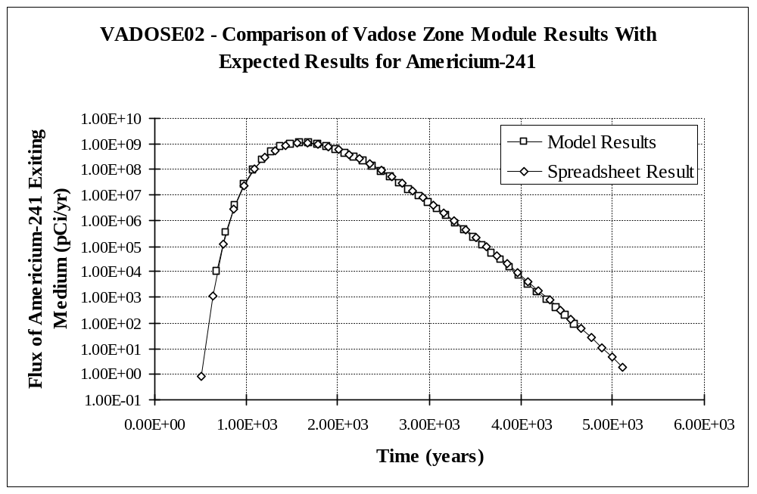

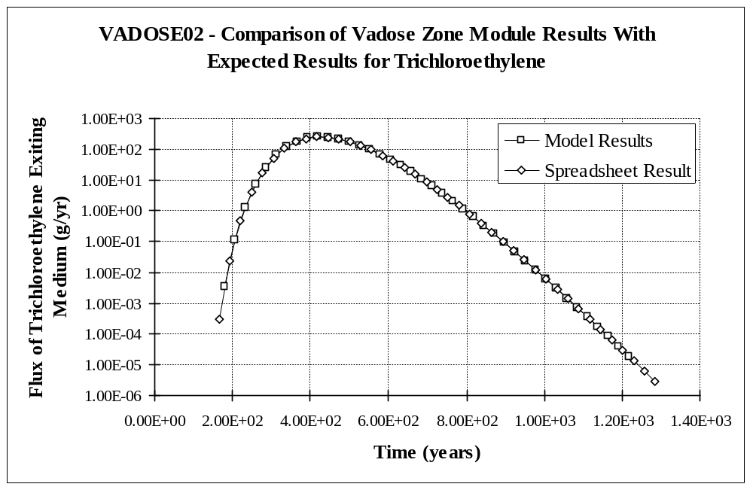

3.3 VADOSE03

3.3.1 Description and Rationale

This case further verifies that contaminant mass (or activity) exiting the medium is being computed correctly, by directly evaluating the numerical solution technique used by the vadose zone module. Acetone and tritium will be released to a vadose zone over a duration equal to approximately 1/5 the travel time through the layer. This will ensure that the numerical solution for a time-varying release will be used (as opposed to the analytical solution for an instantaneous release). A time near the expected peak flux will be chosen, and the mass (or activity) of contaminant exiting the layer will be numerically computed in a spreadsheet and compared to the output of the vadose zone module. In addition, the moisture content calculation will be further verified. The infiltration rate to the layer will be equal to the saturated hydraulic conductivity (thereby simulating a ponded source), so the computed moisure content should equal total porosity.

3.3.2 Input Data

The constituent-specific input data for this case is as follows:

Constituents | Acetone | Tritium (as tritiated water)
Inventory | 12,500 g | 1.47 Ci
Emission Rate | 12,500 g/yr | 1.47 Ci/yr
Emission Duration | 1.0 yrs | 1.0 yrs
Half-life | n/a | 12.4 yrs

The distribution coefficients (Kd’s) for both constituents will be set to the values computed by the MUI (1.10 x 10⁻² mL/g for acetone and 0 mL/g for tritium). The source dimensions and medium physical properties are as follows:

Source Length | 75 m
Source Width | 75 m
Infiltration Rate (darcian) | 1073 cm/yr
Water Flux | 60,356.25 m³/yr
Soil Type | sandy clay
Soil Type Coefficient | 10.40
Sand Content (Wt. basis) | 52 %
Silt Content (Wt. basis) | 7 %
Clay Content (Wt. basis) | 39 %
Organic Matter Content | 2 %
Iron and Aluminum Content | 0 %
pH | 7.0
Layer Thickness | 125 m
Total Porosity | 43.0 %
Field Capacity | 32.0 %
Dry Bulk Density | 1.51 g/cm³
Saturated Hydraulic Conductivity | 3.4 x 10⁻⁵ cm/s
Longitudinal Dispersivity | 1.25 m

3.3.3 Expected Results

The instantaneous mass (or activity) of contaminant exiting the medium (near the peak flux) was calculated using equations in Whelan et al. (1996). The fluxes are expected to be 5,226 g/yr at year 5.16 for acetone, and 4.699 x 10¹¹ pCi/yr at year 4.93 for tritium. These calculations are documented in Appendix A. The actual peak fluxes are expected to occur slightly later in time and be slightly higher.

3.3.4 Baseline Testing Results

The actual (model) results are compared to the expected (spreadsheet) results in the following two charts. The actual results match very well with the expected results.

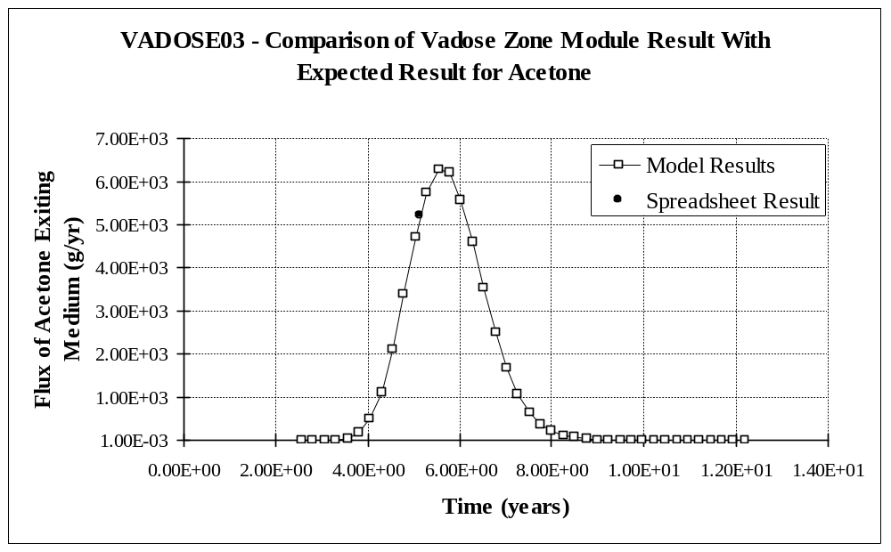

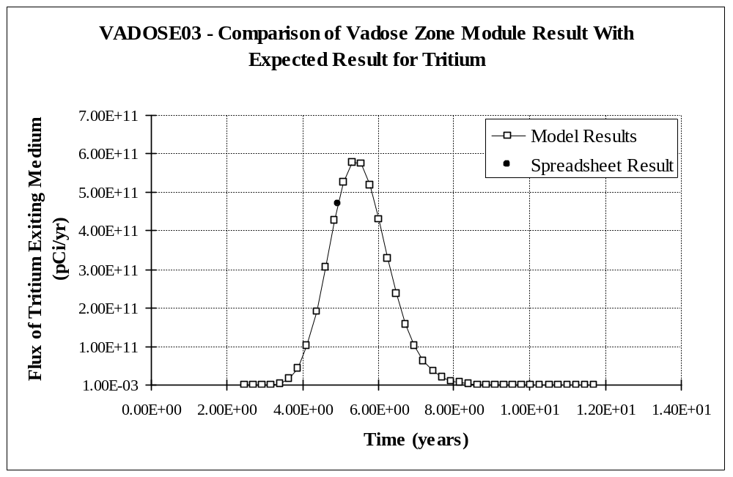
3.4 VADOSE04

3.4.1 Description and Rationale

This case addresses the requirement that there be no limit to the number of constituents considered in a scenario. Twenty-one parent constituents will be selected to demonstrate that the 20-contaminant limit (which was present in MEPAS 3.2 and earlier versions) is no longer a concern for MEPAS 4.1. The parent constituents will include Uranium-238 (which has 8 decay products in MEPAS) thereby testing the requirement that the module be able to handle 9-member decay chains. The endpoint will be contaminant mass (or activity) exiting the medium.

3.4.2 Input Data

The parent constituents will be Americium-241, Cesium-137+D, Iodine-129, Plutonium-240, Technetium-99, Uranium-238, Acetone, Aroclor 1221, Benzo(a)pyrene, Chlorobenzene, Chromium VI, 1,2-Dichloroethylene, Ethylene Glycol, Hexachlorobenzene, Mercury, Naphthalene, Pyrene, Selenium, Toluene, Vinyl Chloride, and Xylene. The source emission to the vadose zone for each constituent will be a unit flux for 100 years. Distribution coefficients (Kd) suggested by the user interface will be used. Other input data is as follows:

Source Length | 50 m
Source Width | 50 m
Infiltration Rate (darcian) | 17 cm/yr
Water Flux | 425,000,000 cm³/yr
Soil Type | sandy loam
Soil Type Coefficient | 4.90
Sand Content (Wt. basis) | 65 %
Silt Content (Wt. basis) | 25 %
Clay Content (Wt. basis) | 7 %
Organic Matter Content | 1 %
Iron and Aluminum Content | 2 %
pH | 5
Layer Thickness | 50.0 m
Total Porosity | 44.2 %
Field Capacity | 17.5 %
Dry Bulk Density | 1.48 g/cm³
Saturated Hydraulic Conductivity | 7.2 x 10⁻⁴ cm/s
Longitudinal Dispersivity | 0.50 m

3.4.3 Expected Results

It is expected that this case will run without error for all 21 parent constituents.

3.4.4 Baseline Testing Results

The model ran to completion without error and produced results for all 21 parent constituents and their progeny.

3.5 VADOSE05

3.5.1 Description and Rationale

This case tests the error handling capability of the vadose zone module. A single constituent will be released to a vadose zone. The minimum number of required flux/time pairs to define a flux versus time function is two. However, in the file specifying the release for this case (*.WFF), only one flux/time pair will be given.

3.5.2 Input Data

Use the same input data as was used for test case VADOSE01, except that for the single flux/time pair, specify a time of zero and a flux of one.

3.5.3 Expected Results

It is expected that an error file (*.ERR) will be created at the start of model execution and that an error message will be generated by the model and written to this file. It is further expected that model execution will immediately cease and that the error will be reported by the Framework User Interface (FUI).

3.5.4 Baseline Testing Results

The module produced an error and terminated execution properly. An error message was written to the *.ERR file, which was shown on the screen when control was returned to the FUI. It should be noted, however, that the error message in the WLS and WRN files, “ERROR --> NUM cannot be less than 2,” is quite cryptic and will not make any sense to most MEPAS users. In this case, NUM is the variable defining the number of flux/time pairs making up the input time series. To properly fix this problem, all the error message in the model should be reworded to better explain the problem to our average user, but funding limitations preclude this from being accomplished now.

3.6 VADOSE06

3.6.1 Description and Rationale

As used in FRAMES, the vadose zone module can be run many times in series to account for layers of different physical characteristics making up the total vadose zone thickness. Therefore, this module must be “system” tested to assure that valid results are obtained under this condition. The concerns are mass conservation and resolution of the results. Test cases VADOSE01, VADOSE02 and VADOSE03 addressed mass conservation and resolution of the results in a single layer. This case makes sure that when the output result of one layer becomes the input to the next, mass will be conserved over many layers without compromising the resolution of the results (i.e., the mass exiting the last layer for non-decaying constituents should equal the mass entering the first layer, and the time period over which the results are reported should still be appropriate).

3.6.2 Input Data

This case will release four, non-decaying, constituents to the vadose zone, all having different sorption characteristics. This will provide a range of total travel times through the total vadose zone thickness. The constituent-specific input data for this case is as follows:

Constituents | Chromium | Cobalt | Manganese | Lead
Kd | 0.0 mL/g | 5.0 mL/g | 15.0 mL/g | 30.0 mL/g
Inventory | 100,000 g | 100,000 g | 100,000 g | 100,000 g
Emission Rate | 100,000 g/yr | 100,000 g/yr | 100,000 g/yr | 100,000 g/yr
Emission Duration | 1 yrs | 1 yrs | 1 yrs | 1 yrs

The infiltration rate and source dimensions are as follows:

Source Length | 25 m
Source Width | 25 m
Infiltration Rate (darcian) | 9.7 cm/yr
Water Flux | 60,625,000 cm³/yr

Holdren et al. (1995) summarized environmental characteristics data for 25 Department of Energy installations in a form suitable for screening level models. The Playa environmental setting at the Pantex Plant (Amarillo, Texas) was chosen as the input data for this case because it offers the largest number of vadose zone layers (seven) of any of the installations. Therefore, this test case will address the following seven layers:

Partially Saturated Zone #1 (PSZ1):
Soil Type | clay loam
Soil Type Coefficient | 8.52
Sand Content (Wt. basis) | 31 %
Silt Content (Wt. basis) | 36 %
Clay Content (Wt. basis) | 33 %
Organic Matter Content | 0 %
Iron and Aluminum Content | 0 %
pH | 8.2
Layer Thickness | 12.2 m
Total Porosity | 47.7 %
Field Capacity | 34.0 %
Dry Bulk Density | 1.39 g/cm³
Saturated Hydraulic Conductivity | 0.15 m/day
Longitudinal Dispersivity | 0.12 m

PSZ2:
Soil Type | sandy clay loam
Soil Type Coefficient | 7.12
Sand Content (Wt. basis) | 60 %
Silt Content (Wt. basis) | 14 %
Clay Content (Wt. basis) | 26 %
Organic Matter Content | 0 %
Iron and Aluminum Content | 0 %
pH | 8.2
Layer Thickness | 6.1 m
Total Porosity | 39.8 %
Field Capacity | 24.0 %
Dry Bulk Density | 1.60 g/cm³
Saturated Hydraulic Conductivity | 0.50 m/day
Longitudinal Dispersivity | 0.060 m

PSZ3:
Soil Type | loamy sand
Soil Type Coefficient | 4.38
Sand Content (Wt. basis) | 84 %
Silt Content (Wt. basis) | 12 %
Clay Content (Wt. basis) | 4 %
Organic Matter Content | 0 %
Iron and Aluminum Content | 0 %
pH | 8.2
Layer Thickness | 53.5 m
Total Porosity | 43.7 %
Field Capacity | 12.0 %
Dry Bulk Density | 1.49 g/cm³
Saturated Hydraulic Conductivity | 98.1 m/day
Longitudinal Dispersivity | 0.53 m

PSZ4:
Soil Type | loamy sand
Soil Type Coefficient | 4.38
Sand Content (Wt. basis) | 84 %
Silt Content (Wt. basis) | 12 %
Clay Content (Wt. basis) | 4 %
Organic Matter Content | 0 %
Iron and Aluminum Content | 0 %
pH | 8.2
Layer Thickness | 15.2 m
Total Porosity | 43.7 %
Field Capacity | 12.0 %
Dry Bulk Density | 1.49 g/cm³
Saturated Hydraulic Conductivity | 98.1 m/day
Longitudinal Dispersivity | 0.15 m

PSZ5:
Soil Type | clay
Soil Type Coefficient | 11.4
Sand Content (Wt. basis) | 35 %
Silt Content (Wt. basis) | 15 %
Clay Content (Wt. basis) | 50 %
Organic Matter Content | 0 %
Iron and Aluminum Content | 0 %
pH | 8.2
Layer Thickness | 12.2 m
Total Porosity | 47.5 %
Field Capacity | 40.0 %
Dry Bulk Density | 1.39 g/cm³
Saturated Hydraulic Conductivity | 2.4 x 10⁻³ m/day
Longitudinal Dispersivity | 0.12 m

PSZ6:
Soil Type | sand
Soil Type Coefficient | 4.05
Sand Content (Wt. basis) | 95 %
Silt Content (Wt. basis) | 3 %
Clay Content (Wt. basis) | 2 %
Organic Matter Content | 0 %
Iron and Aluminum Content | 0 %
pH | 7.0
Layer Thickness | 27.4 m
Total Porosity | 38.0 %
Field Capacity | 9.0 %
Dry Bulk Density | 1.64 g/cm³
Saturated Hydraulic Conductivity | 880.9 m/day
Longitudinal Dispersivity | 0.27 m

PSZ7:
Soil Type | sand
Soil Type Coefficient | 4.05
Sand Content (Wt. basis) | 95 %
Silt Content (Wt. basis) | 3 %
Clay Content (Wt. basis) | 2 %
Organic Matter Content | 0 %
Iron and Aluminum Content | 0 %
pH | 7.0
Layer Thickness | 9.1 m
Total Porosity | 38.0 %
Field Capacity | 9.0 %
Dry Bulk Density | 1.64 g/cm³
Saturated Hydraulic Conductivity | 880.9 m/day
Longitudinal Dispersivity | 0.091 m

3.6.3 Expected Results

It is expected that the mass exiting the last layer for each contaminant will equal the mass released to the first layer, and that the resolution of the data will be appropriate.

3.6.4 Baseline Testing Results

The following table gives the mass conservation percentage for each constituent in each layer. For all constituents and all layers, the mass conservation error was less than one percent. Therefore, mass was conserved throughout the simulation.

Layer | Percentage of Mass Released from Source Exiting Each Layer
Layer | Chromium III | Cobalt | Manganese | Lead
PSZ1 | 100.01 | 99.99 | 100.00 | 100.00
PSZ2 | 100.06 | 100.02 | 99.97 | 99.98
PSZ3 | 99.93 | 100.11 | 99.84 | 99.90
PSZ4 | 100.02 | 100.17 | 99.91 | 100.00
PSZ5 | 100.28 | 99.87 | 100.01 | 99.64
PSZ6 | 100.49 | 99.26 | 99.66 | 100.11
PSZ7 | 100.44 | 99.37 | 99.39 | 99.91

The time periods over which the mass flux is reported are excellent for all constituents and all layers. Forty-one records were output for each constituent in each layer. In all cases, at least 39 records reported non-zero concentrations. Only the first reported concentration in a time series or the last reported concentration were ever equal to zero.

4.0 Module Limitations

The module currently does not meet the requirement that it read and write an unlimited number of flux records. The model would have to be rewritten to meet this requirement. However, the module can consider an unlimited number of parent contaminants and scenarios, both of which were limitations of MEPAS 3.2.

Another limitation is that some of the error messages written to the WLS file are somewhat cryptic and are generally only understandable by the programmer. For funding reasons, it was decided not to deal with this issue for MEPAS 4.1/FRAMES 1.1. Users can certainly contact our organization if an error occurs and they cannot understand the error message.

Another potential limitation should be pointed out, although it did not show up in this testing. Because of the way that decay products entering a layer are simulated, it’s possible that the mass flux exiting the layer for decay products may be inappropiately resolved in the output results. The vadose zone module can only directly simulate the migration of parent constituents through a layer. It uses the parent results to compute the results for the progeny. In effect, this means that decay products have the same transport properties as their parent. Because of this, all constituents entering the layer (parents and progeny) are treated as parents with their own decay chains. For example, consider the three member chain Cm-245 decaying to Pu-241 whichs decays to Am-241 (this chain was used in test case VADOSE02). The vadose zone module will treat Cm-245 as a parent having two decay products, Pu-241 and Am-241. It would also treat Pu-241 as a parent which decays to Am-241. Finally, it would treat Am-241 as a parent with no progeny. The module then computes a single time series of activity fluxes exiting the layer for Cm-245, two time series for Pu-241 (Pu-241 as a parent and Pu-241 as a decay product of Cm-245), and three time series for Am-241 (parent, decay product of Pu-241, and second decay product of Cm-245). The output results consisting of two time series for Pu-241 must be summed together, and likewise for the three time series for Am-241. If the Kd’s (or possibly the half-lives) for these constituents are significantly different, the time periods of these series might be very different. The summed series will have a time period that is all inclusive of the times of the series being summed and contain no more records than is in either series individually. Therefore, resolution of the shorter time series could be lost, and a peak flux could be missed. One method that could prevent this situation from occurring is to keep the Kd’s for the progeny the same as the parent. If the user elects to use significantly different Kd’s, the user should carefully check the activity fluxes exiting the medium to see if a peak flux was potentially missed.

5.0 References

Holdren, G. R., C. S. Glantz, L. K. Berg, K. Delinger, C. J. Fosmire, S. M. Goodwin, J. R. Rustad, R. Schalla, J. A. Schramke. 1995. Environmental Settings for Selected U.S. Department of Energy Installations-- Support Information for the Programmatic Environmental Impact Statement and the Baseline Environmental Management Report. PNL-10550, Pacific Northwest Laboratory, Richland, Washington.

Strenge, D. L. and S. R. Peterson. 1989. Chemical Data Bases for the Multimedia Environmental Pollutant Assessment System (MEPAS): Version 1. PNL-7145, Pacific Northwest Laboratory, Richland, Washington.

Whelan, G., J. P. McDonald, and C. Sato. 1996. Multimedia Environmental Pollutant Assessment System (MEPAS): Groundwater Pathway Formulations. PNNL-10907, Pacific Northwest National Laboratory, Richland, Washington.

Whelan G., K. J. Castleton, J. W. Buck, G. M. Gelston, B. L. Hoopes, M. A. Pelton, D. L. Strenge, and R. N. Kickert. 1997. Concepts of a Framework for Risk Analysis in Multimedia Environmental Systems (FRAMES). PNNL-11748, Pacific Northwest National Laboratory, Richland, Washington.
Appendix A
Expected Results Documentation

This appendix documents the mathematical calculations performed to determine the expected results for the first three test cases in this plan. The calculations were performed using a commercial spreadsheet package (Microsoft Excel 97). Two versions of each spreadsheet are presented. The first shows the values resulting from all formulas, and the second shows the formulas themselves.

VADOSE01 Expected Results.xls

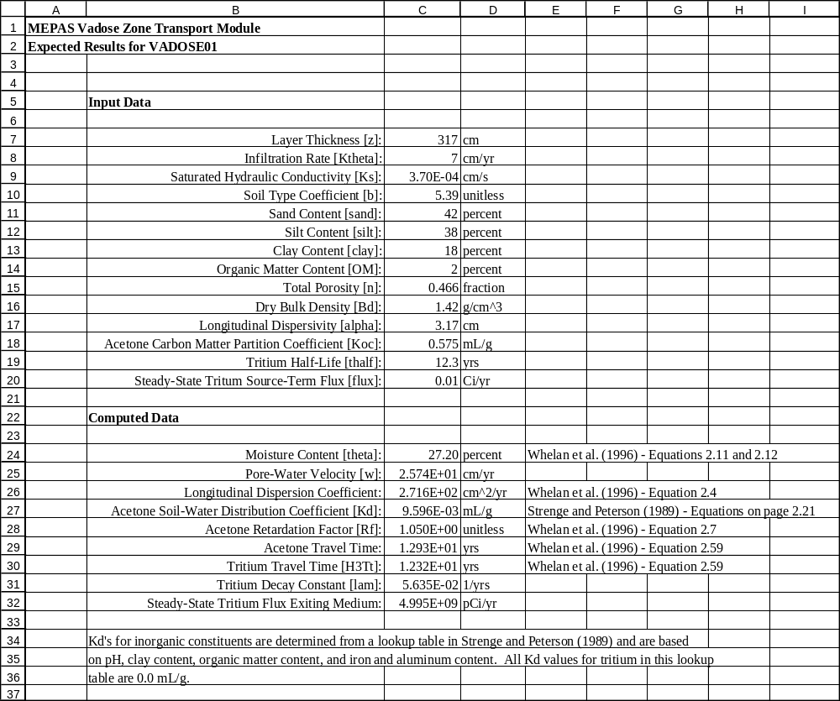

VADOSE01 Expected Results.xls (formulas)

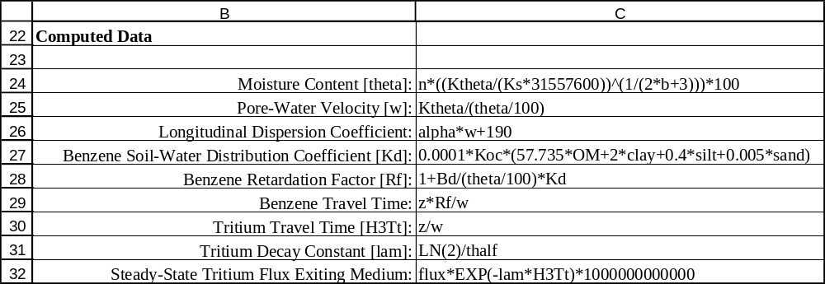

VADOSE02 Expected Results.xls

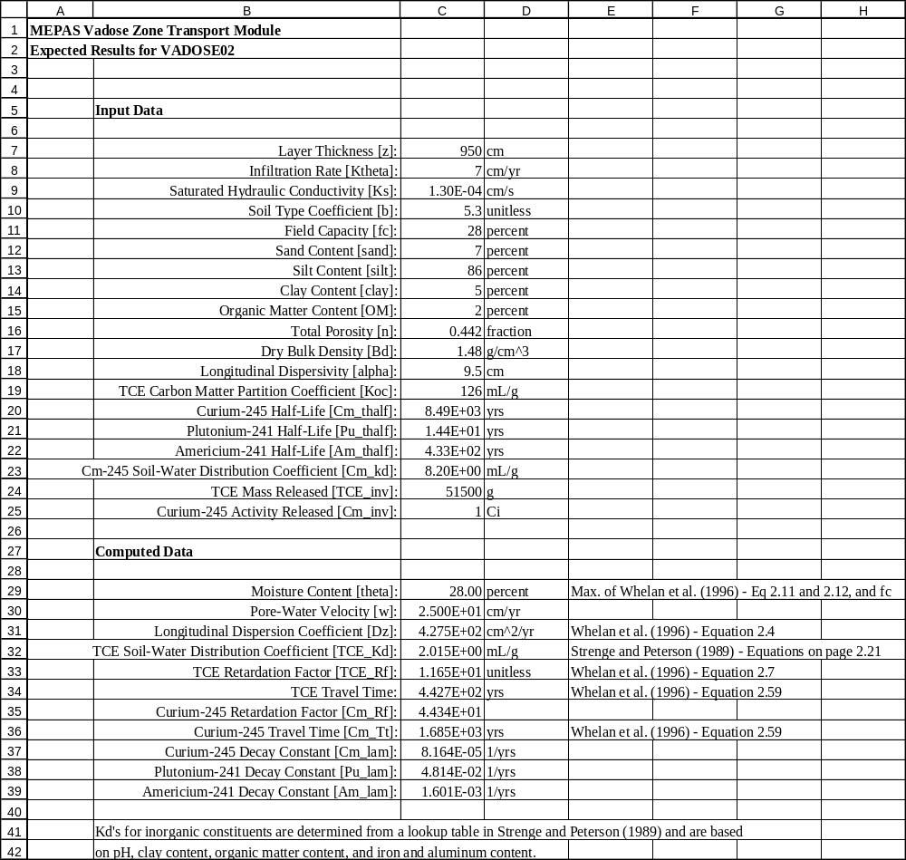
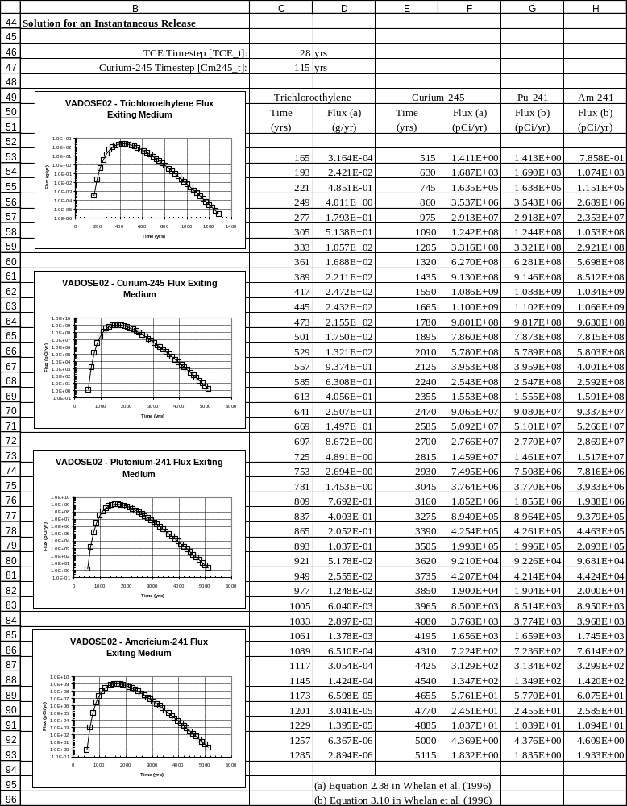

VADOSE02 Expected Results.xls (formulas)

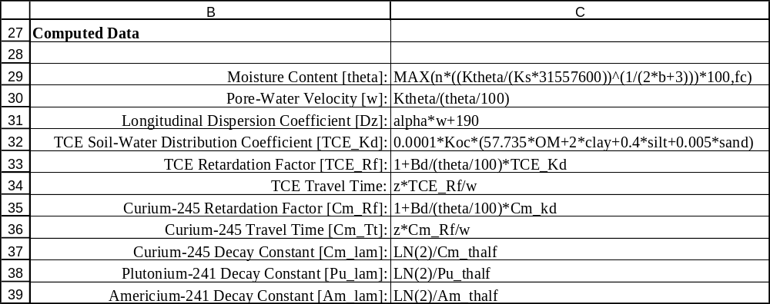
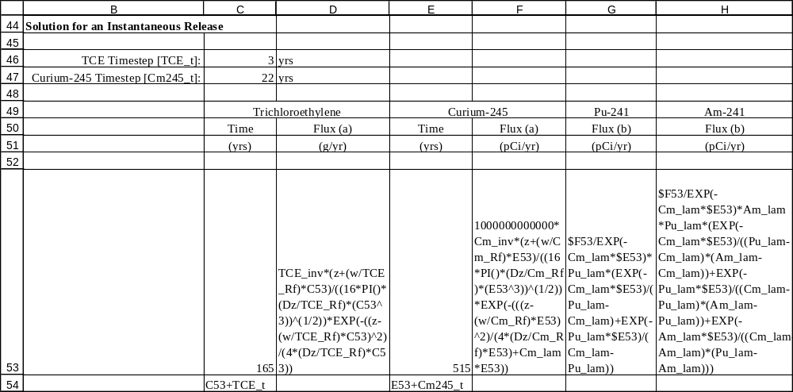
VADOSE03 Expected Results.xls

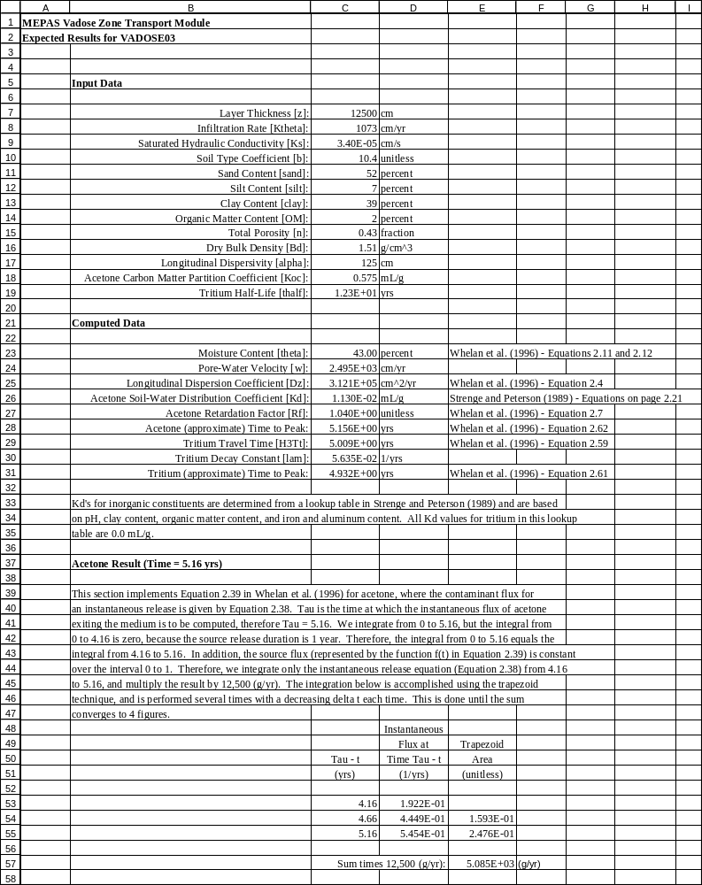
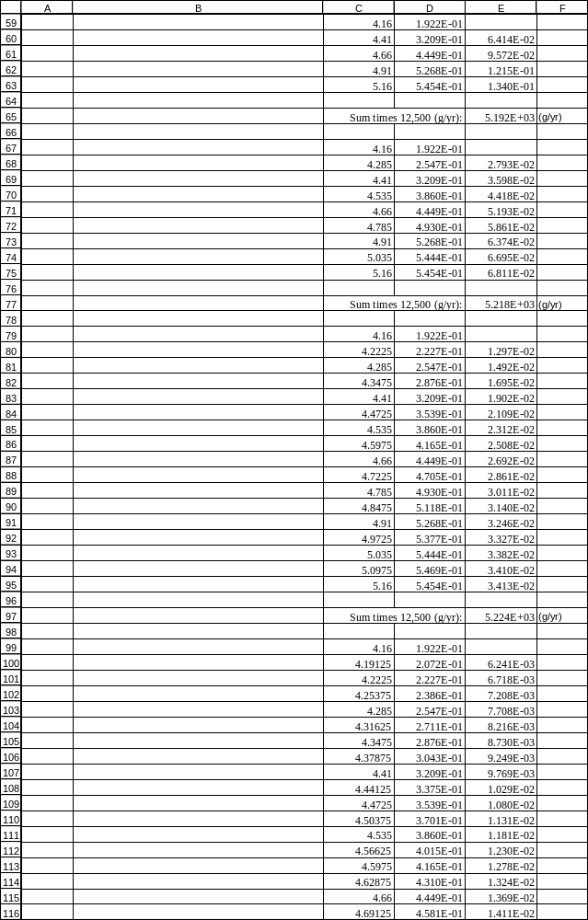
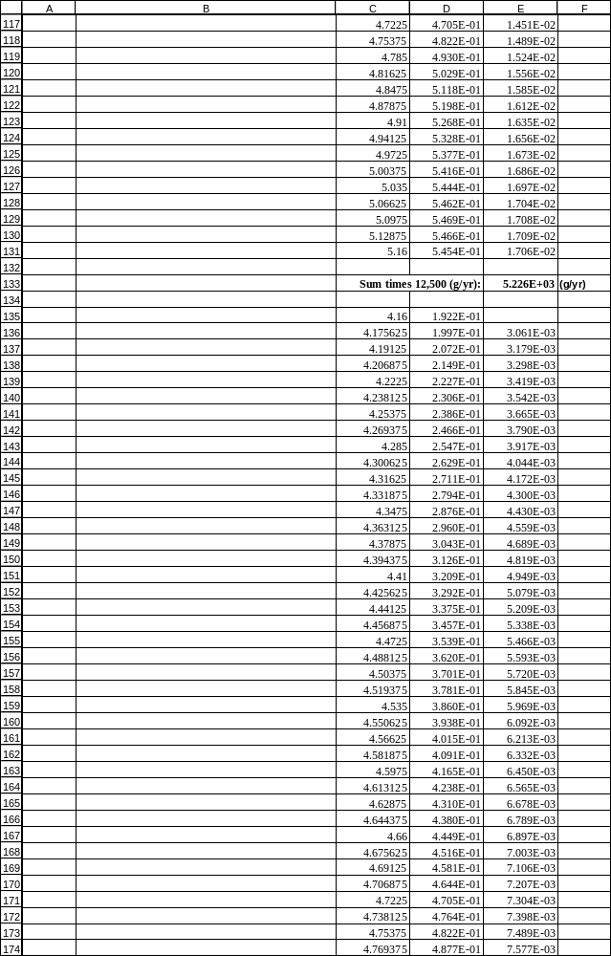
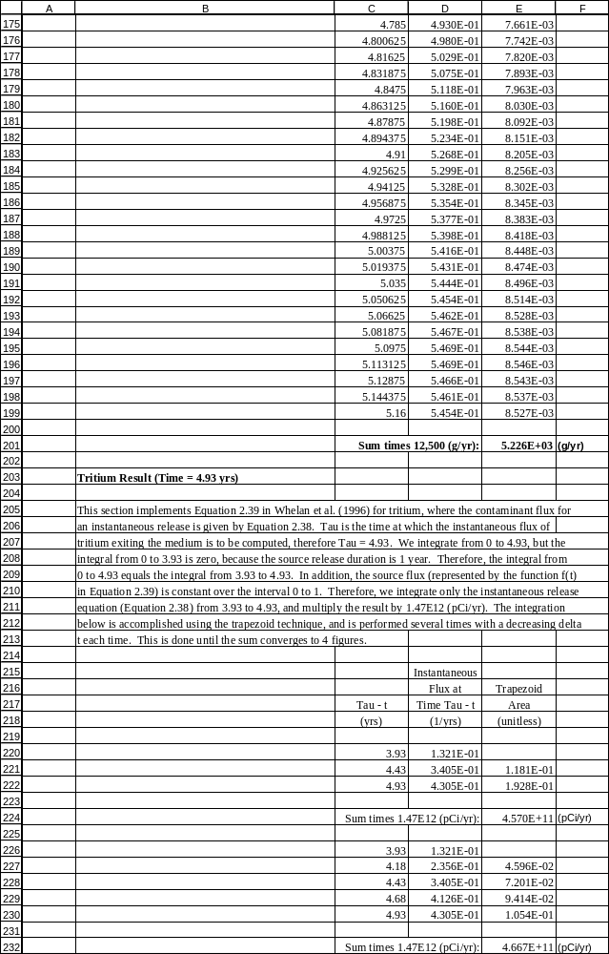
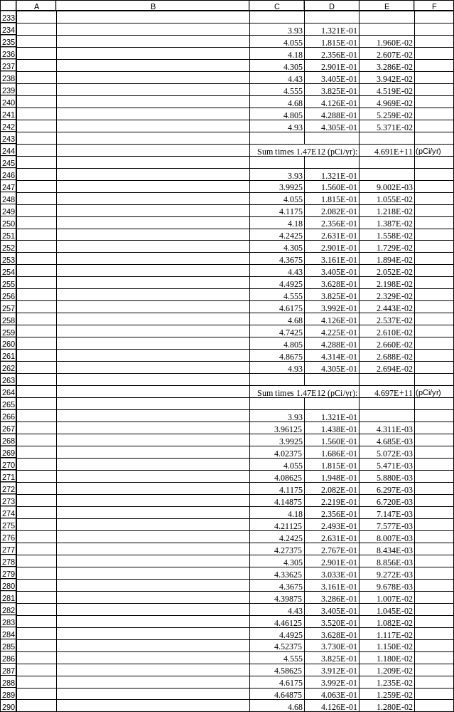
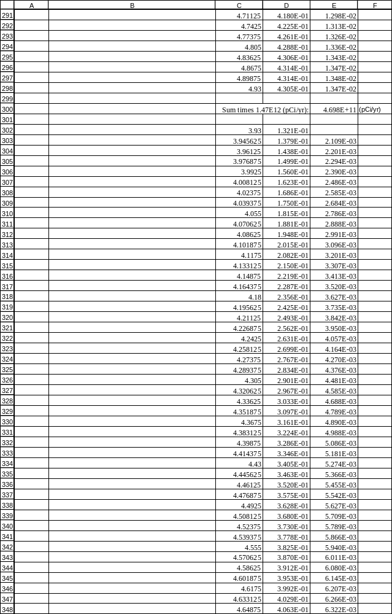
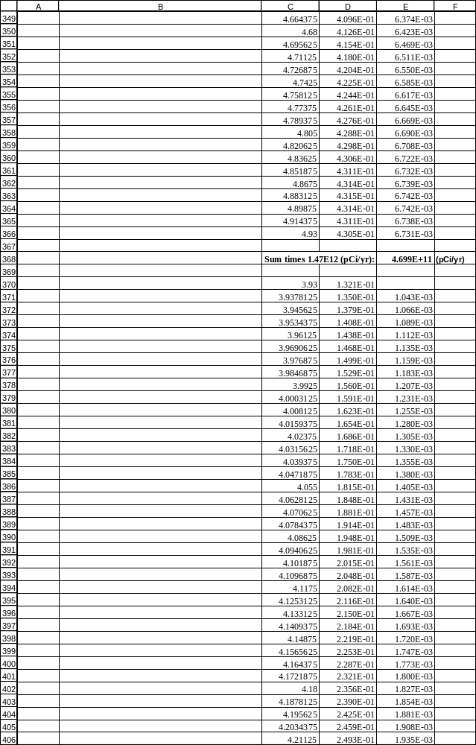
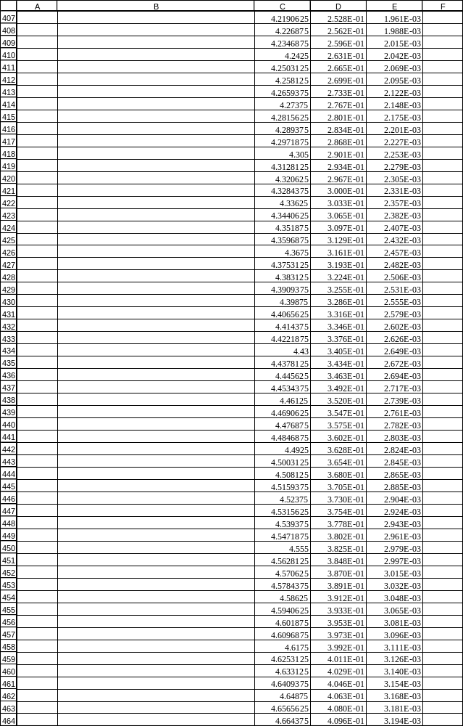
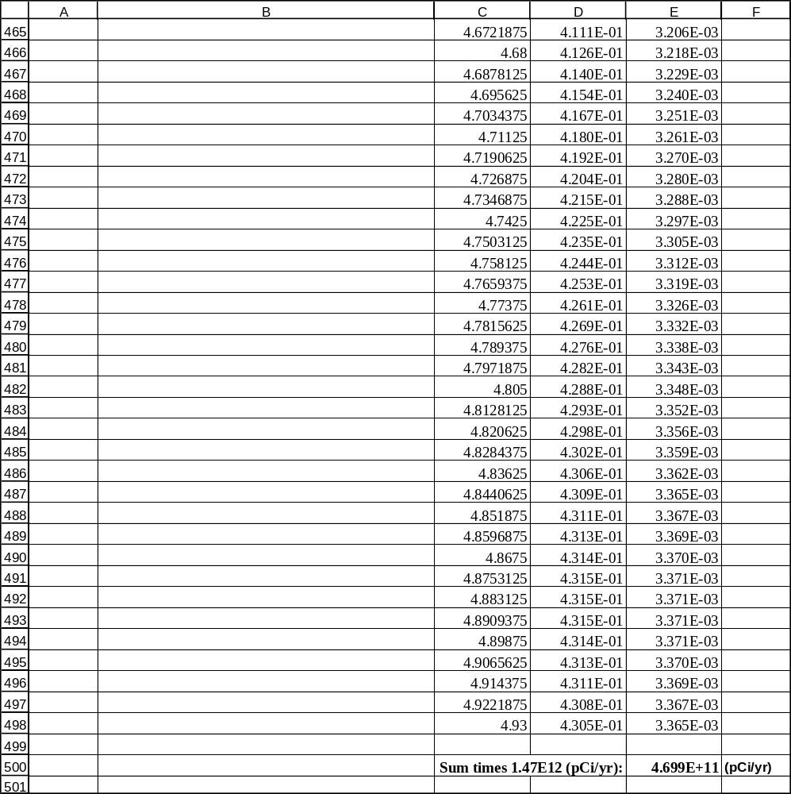

VADOSE03 Expected Results.xls (formulas)

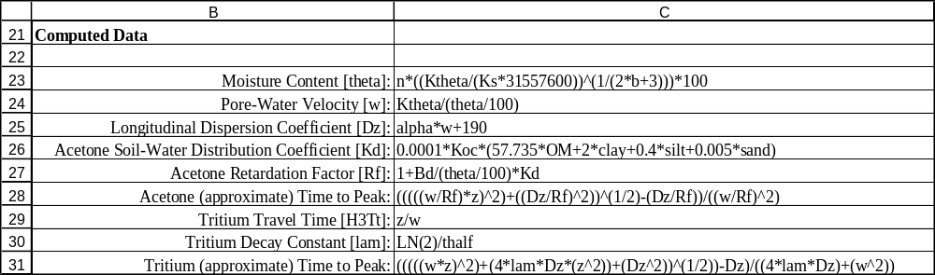
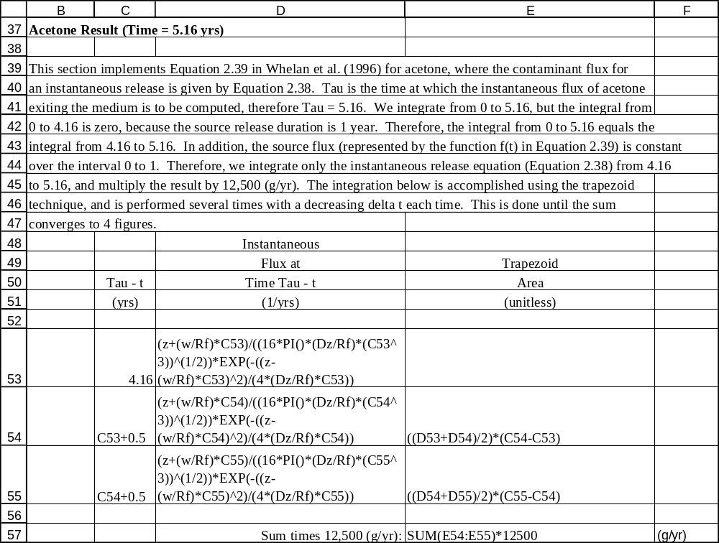

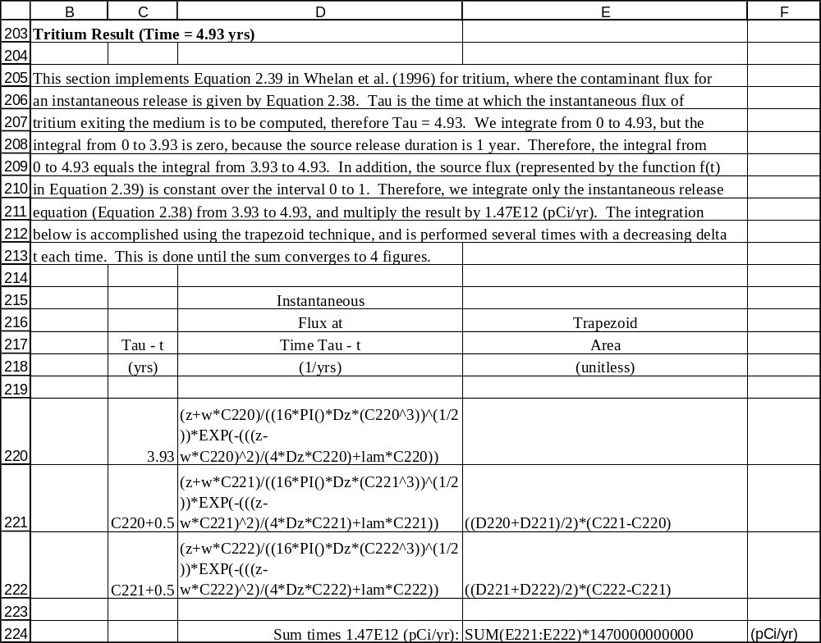

Appendix B
General Procedure for Conducting the Tests

This appendix describes the general procedure for conducting the tests in this plan. After starting FRAMES, click on the “Contaminant Selection” button on the toolbar to add this icon to the workspace. Double click on the workspace icon, click ‘OK’, name the *.GID file the same as the name of the test (e.g., vadose01), and select the contaminants to be used in the test and click ‘OK’. Then, build the rest of the conceptual-model picture by selecting the “Source” button and dragging this icon to the workspace, followed by dragging the “Vadose Zone” icon to the workspace. Position the mouse cursor over the “Source” icon, and while holding down the “Shift” key, use the left mouse button to drag from the source icon to the vadose zone icon to add an arrow.

To select a specific source model, double click on the source icon, select “FRAMES Known Contaminant Flux or Concentration,” name the icon using the “Label” field if desired, then ckick “OK.” The user interface for this module then appears with a “Water Flux” tab only. Enter the source width and length into the “Width of flux plane” and “Length of flux plane” fields. The next two fields, “Distance from water table” and “Natural discharge rate,” are not used by the MEPAS vadose zone module, so just enter zero in these fields. The next thing is to enter the infiltration rate and the contaminant mass fluxes as time series. The water flux series should be from year 0 to year 10,000. The value of the water flux is the infiltration rate times the area of the source (only a single, constant infiltration rate can be used with the MEPAS vadose zone module). Use the drop down menu or the side-to-side arrows to select each contaminant and enter the source flux time series as defined in the input data section for the test case. After entering all the data, select “Save and Exit” from the file menu. Then, double click on the source icon to run the source module.

To define the vadose zone, double click on the vadose zone icon, select “MEPAS Vadose Zone,” name the icon if desired, and then click ‘OK’. The user interface for this module then appears. Proceed to enter the physical characteristics of the vadose zone along with the Kd’s for each constituent as directed in the input data section for the test case. When data entry is complete, select “Save and Exit” from the file menu. Double click on the icon to run the module.

Flux output results are contained in the *.WFF file, where the * is the name of the test case (i.e., the name assigned to the GID file). The viewer icon within FRAMES can be used to view these files, or a spreadsheet package can be used to load these files for viewing or data analysis. To use the viewer, drag the “Data Viewer” icon from the toolbar to the workspace, and drag an arrow using the right mouse button from the vadose icon to the viewer icon (dragging from the viewer icon to the vadose icon won’t work). To view the WLS and WIN files, use a text editor or word processor. These files reside in the same directory in which the GID file is saved, and have the same name as the GID file with the WLS or WIN extension.

